Alpha - Version
User Experience Template
Project Overview
Project Manager: Bhekabona Mbhele
Project: Sand Mixer Report System
Plant: High Chrome Ball Plant
Version: 1.0.0.0
Prepared by: Tsundzukani Nkuna
From Date: 2025/ 06/ 27 To Date: 2025/ 06/ 30
Project Objectives: The objective of the project is to provide easy and convenient access to the sand batch records across the three casting sections at High Chrome Ball Plant.
Table of Contents
Introduction 2
1.1 Business Goals: 2
1.2. Scope 2
1.3. Intended Audience 2
1.4 Constraints 3
USER MAPPING 3
2.1 User-Story Map Figure 3
WIRE FRAMES 4
3.1 Low-Fidelity 4
Production Line 1 Mixer Sand Batch Wire Frame 4
Production Line 2 Mixer Sand Batch Wire Frame 5
Production Line 3 Mixer Sand Batch Wire Frame 5
MOCK UPS 6
4.1 Mid-Fidelity 6
Production Line 1 Mixer Sand Batch Mock Ups 6
Production Line 2 Mixer Sand Batch Mock Ups 6
Production Line 3 Mixer Sand Batch Mock Ups 7
PROTOTYPES 8
5.1 High-Fidelity 8
Production Line 1 Mixer Sand Batch Prototype 8
Production Line 2 Mixer Sand Batch Prototype 9
Production Line 3 Mixer Sand Batch Prototype 9
CONCLUSION 10

Introduction

1.1 Business Goals:
The Sand Mixer Report System for the High-Chrome Ball Plant is being developed to automate the collection, storage, and presentation of sand-batch data from Line 1, Line 2, and Line 3. For each sand batches produced on a given day.

1.2. Scope
- Connect to a HCBP SQL SERVER AUT-ENG\GM_PRODUCTION to retrieve Mixer Sand-Batch results which is automatically stored and saved to the HCBP-SQL-server from the Scada and thereafter warehoused in AUT-ENG database.
- The system stores all batch records processed through the Sand plant Scada, for each casting line.
- The data accuracy, that is recorded through the Sand plant PLC and Scada is dependent on the scale’s standardization.
- Duplicate entries for the same Lines, date, and time must be filtered in the final app report.
- The app has no access limitations and End-users can view and export data only, no edits are made possible to the information presented in the app.
- Managers and Technicians can upload, edit, and annotate results before final validation.
- Engineers have read-only access to the reports accessed in the app.
- The report can be extracted into excel format, for further processing
- Sand-Batch Report records must include both date and time stamps for traceability.
- Entries older than 5 years may be archived but not deleted
- The system must be accessible during standard plant operating hours (24/7), with scheduled downtime communicated 24 hours in advance.
- Automatic backups of all Sand-Batch Report data must occur every 24 hours.
- The system should retrieve and display query results within 3 seconds for normal data ranges.
- The system presents past day batch records, timed as 7H00 to 7H00.

1.3. Intended Audience
- End -User / Operator
- Managers and Technicians
- Engineers

1.4 Constraints
- Development Start: 25 June 2025
- Testing Phase: Frequently after Updates
- Go-Live: Frequently after Updates approval
- Team:
  - MIS Technician
- Technology:
  - IIS (Internet Information Services)
  - SQL Server
  - ASP.NET stack

USER MAPPING

2.1 User-Story Map Figure
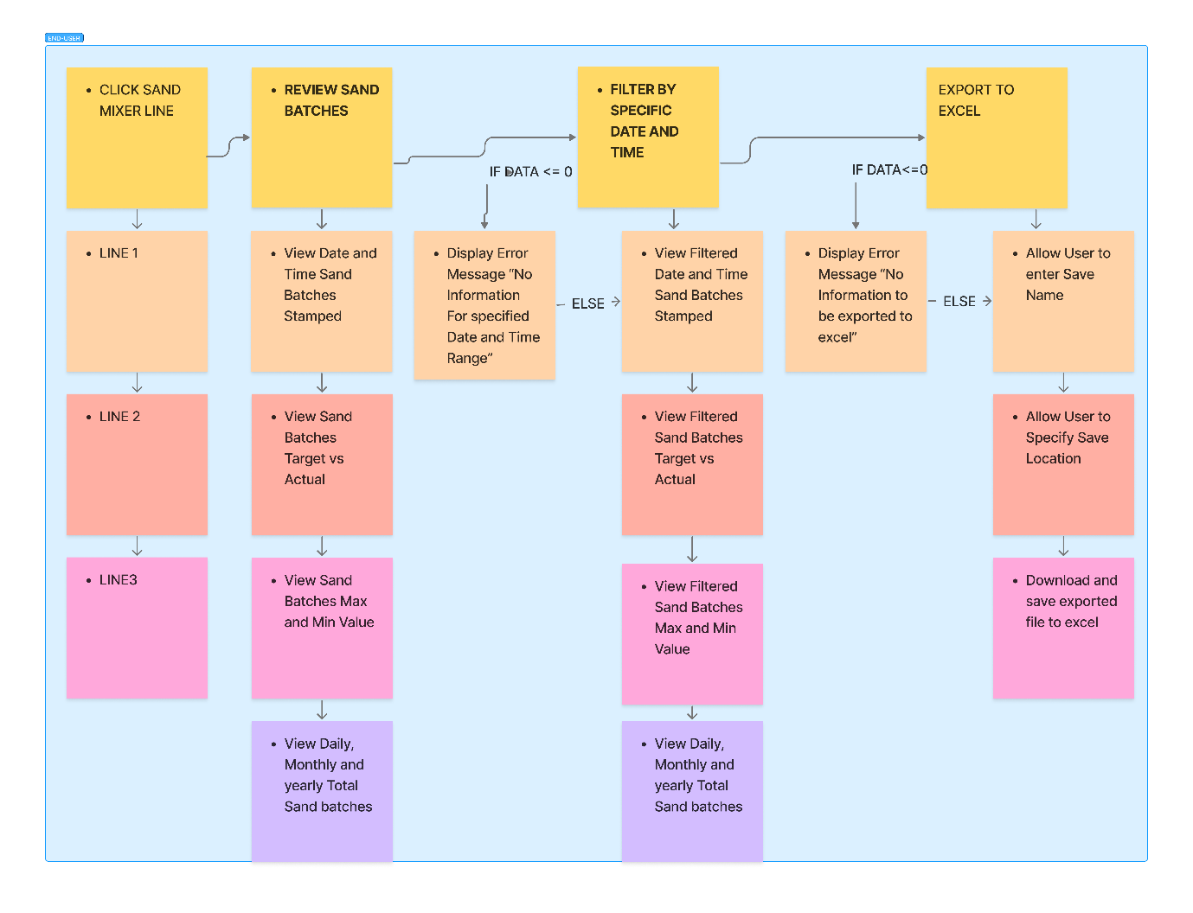

WIRE FRAMES

3.1 Low-Fidelity

Production Line 1 Mixer Sand Batch Wire Frame
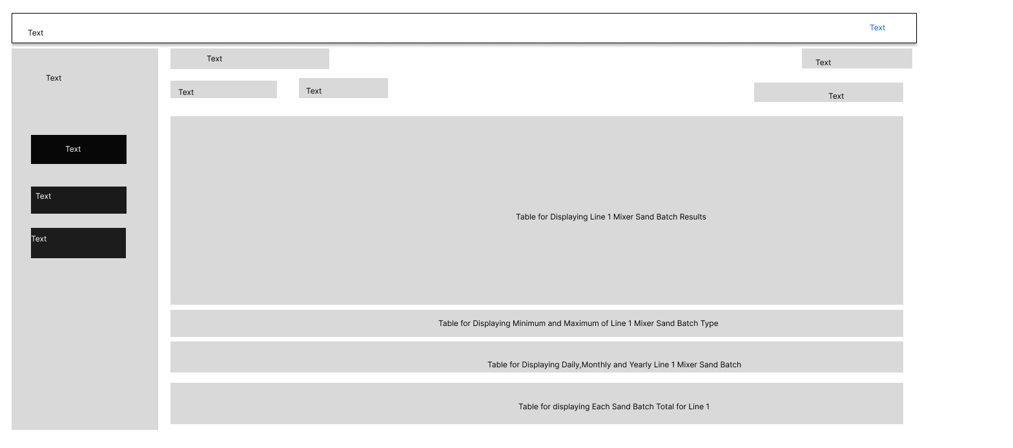

Production Line 2 Mixer Sand Batch Wire Frame
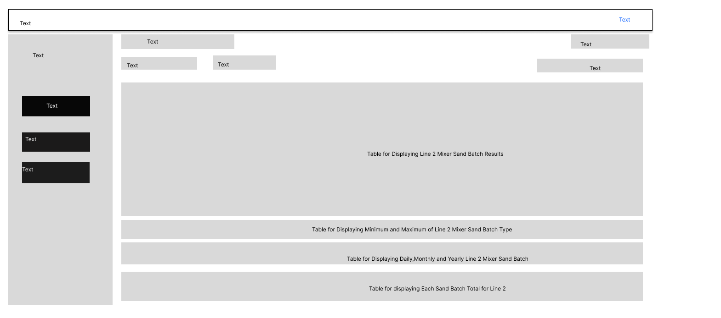

Production Line 3 Mixer Sand Batch Wire Frame
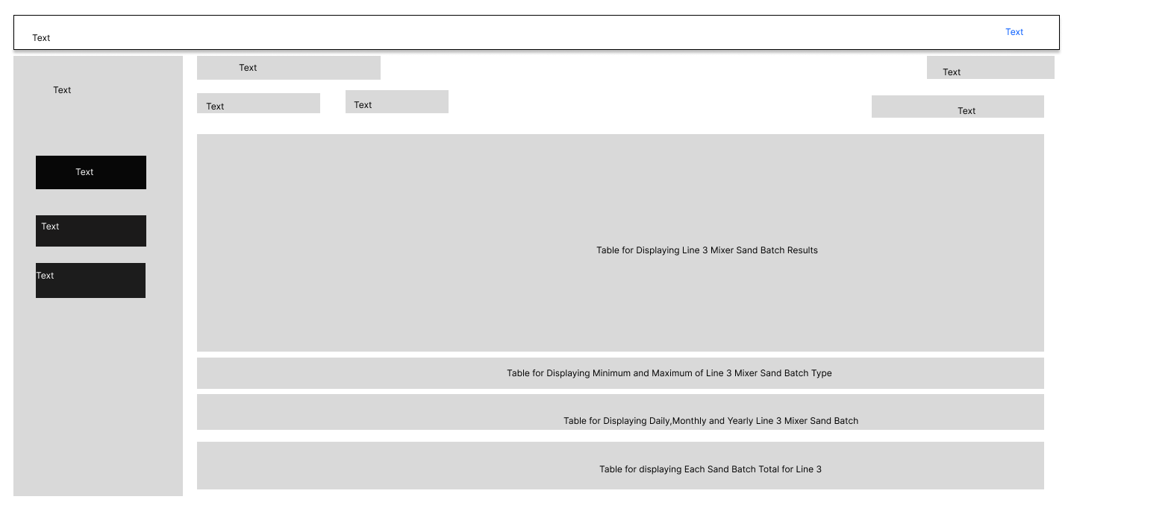

MOCK UPS

4.1 Mid-Fidelity

Production Line 1 Mixer Sand Batch Mock Ups
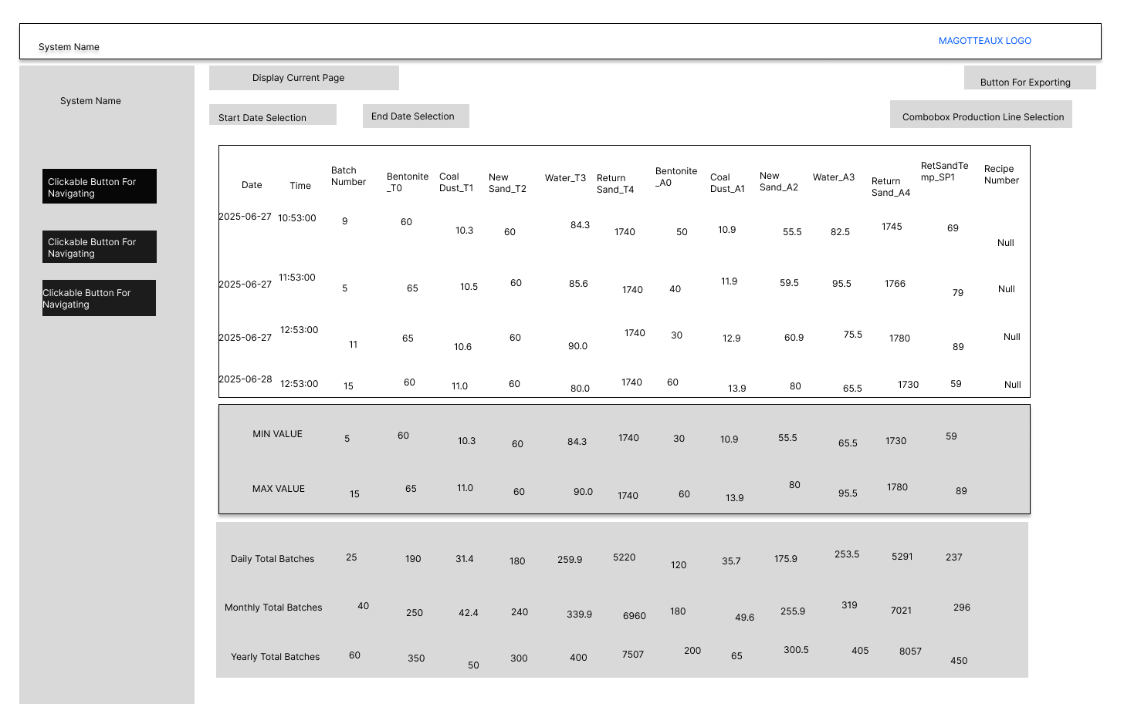

Production Line 2 Mixer Sand Batch Mock Ups

Production Line 3 Mixer Sand Batch Mock Ups

PROTOTYPES

5.1 High-Fidelity

Production Line 1 Mixer Sand Batch Prototype
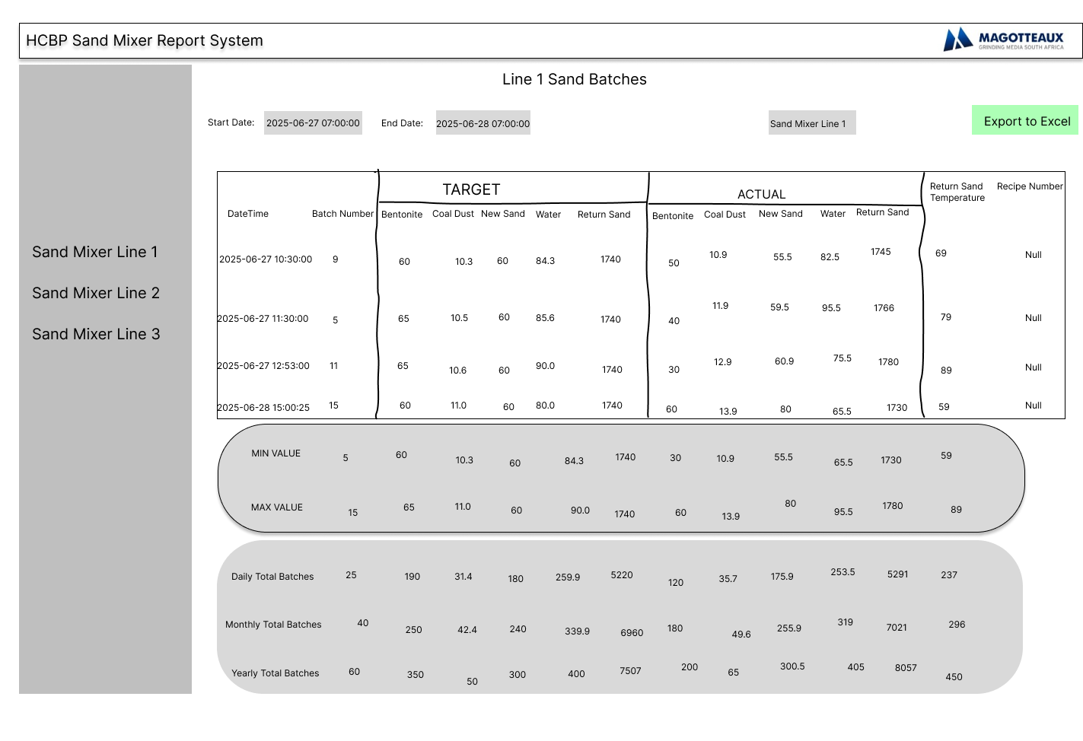

Production Line 2 Mixer Sand Batch Prototype
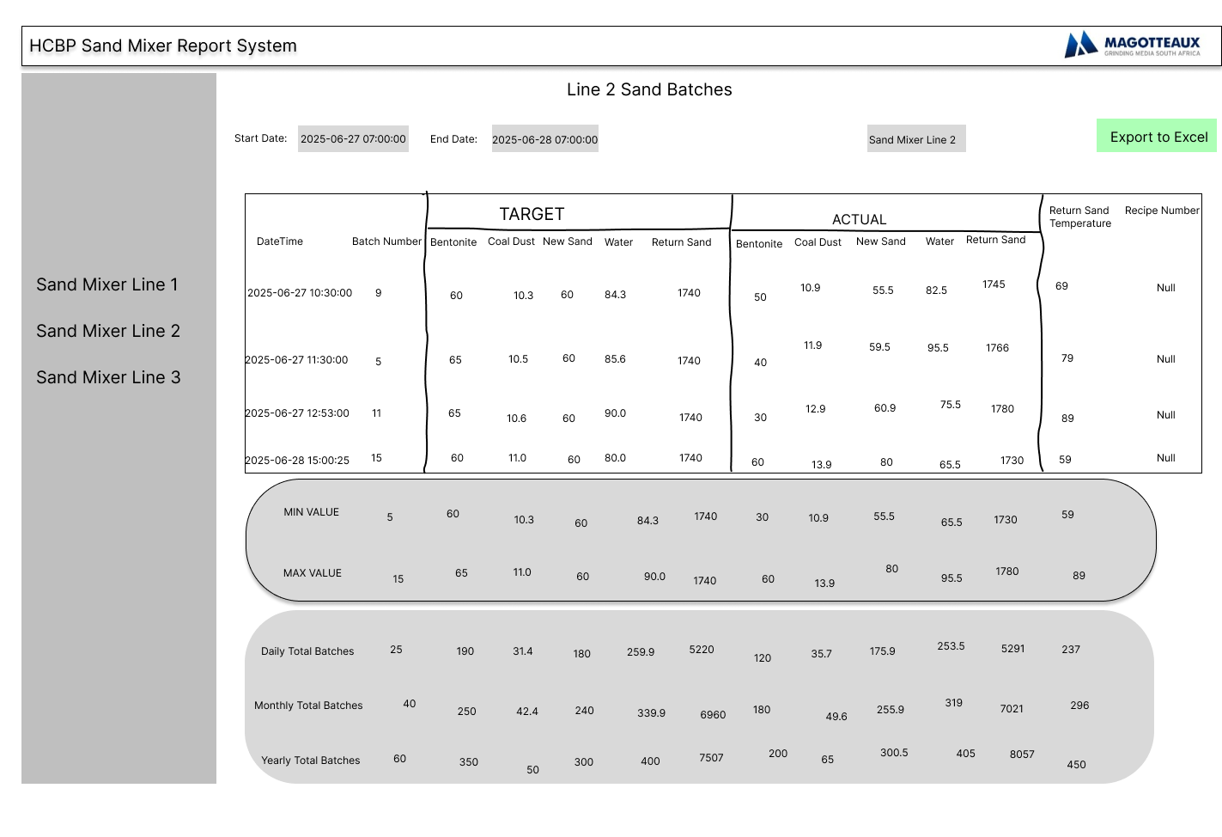

Production Line 3 Mixer Sand Batch Prototype
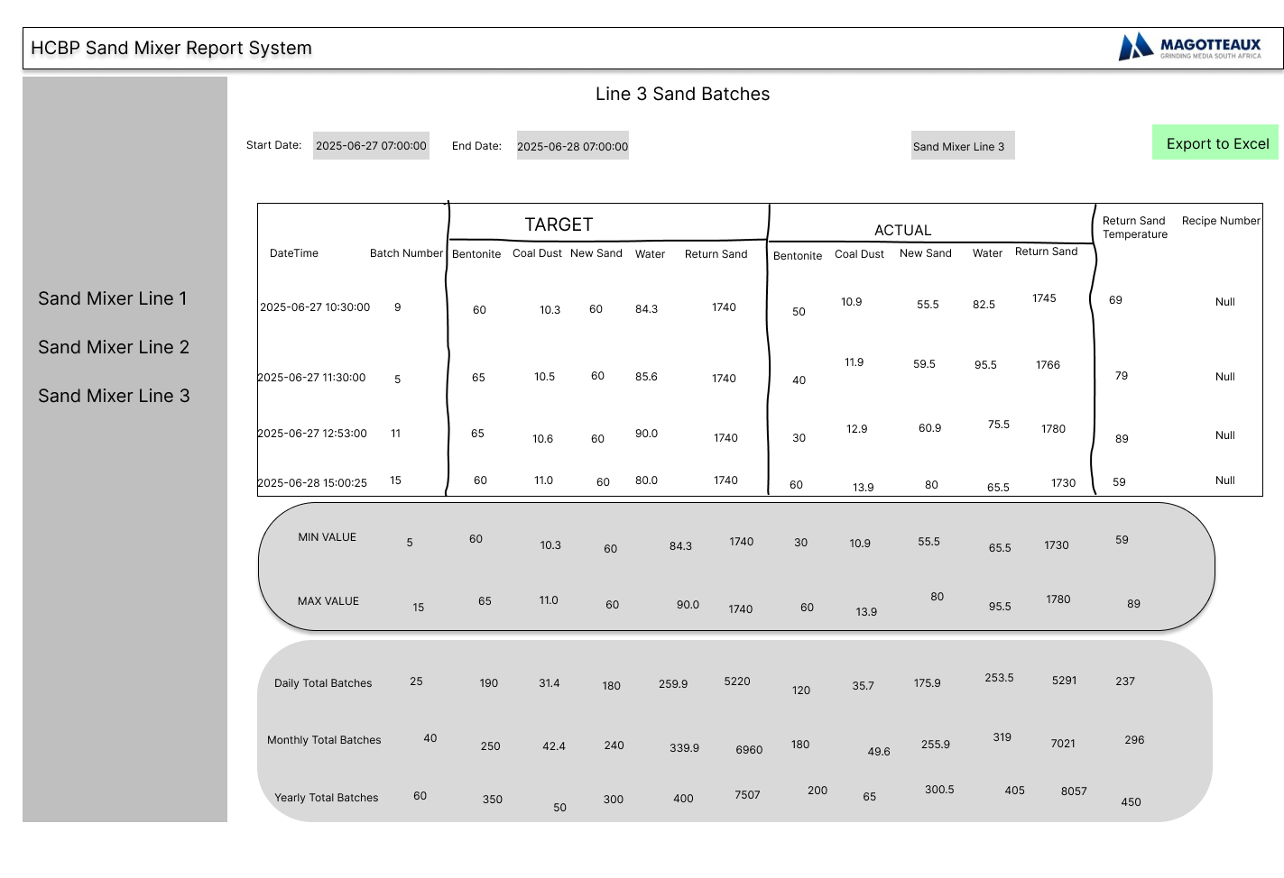

CONCLUSION
This Alpha version delivers a purpose-built, user-cantered interface for the Sand Mixer Report System at the High Chrome Ball Plant—designed to Display real-time monitoring and data traceability. It automatically connects to AUT-ENG SQL Server, filters duplicate, timestamps each sand-batch record, and offers intuitive export-to-Excel functionality. Access levels are clearly defined for End-Users.

